**DAYS-05:**

**Testing, Error Handling, and Backend Integration Refinement-Avion Objective:**

Day 5 focuses on preparing your marketplace for real-world deployment by ensuring all components are thoroughly tested, optimized for performance, and ready to handle customer-facing traffic. The key tasks include backend integration testing, error handling implementation, performance optimization, cross-browser/device testing, security validation, and User Acceptance Testing (UAT). Key Areas of Focus 1. Functional Testing 2. Error Handling 3. Performance Optimization 4. Cross-Browser and Device Testing 5. Security Testing 6. User Acceptance Testing (UAT)

**Step 1**: Functional Testing Test Core Features: ● Product Listing: Ensured that products are displayed correctly across platform. ● Filters and Search: Validated search functionality, though a slight error was identified in search results where the accuracy needed improvement. ● Cart Operations: Tested adding, updating, and removing items from the cart. All operations were functioning as expected. ● Dynamic Routing: Verified that individual product detail pages load correctly without any issues. Testing Tools Used: ● Thunder Client: For API response testing. ● React Testing Library: For component behavior testing

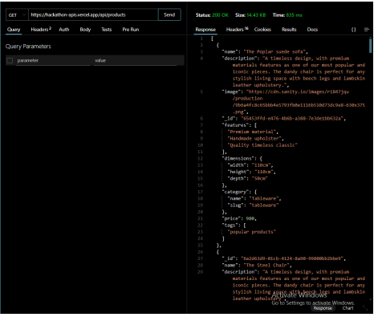

**Step 2**: Error Handling API Error Handling: ● Implemented try-catch blocks to handle API errors and display appropriate error messages. Fallback UI: ● In case of unavailable data (e.g., no products), fallback UI elements were displayed, such as a "No items found" message for an empty product list.

**Step 3:** Performance Optimization Optimize Assets: ● Used lazy loading for large images and assets to improve performance and reduce load time. Analyze Performance: ● Utilized Lighthouse to analyze performance, identifying areas for improvement. ● Implemented performance fixes, including reducing unused CSS, enabling browser caching, and optimizing JavaScript bundles. Test Load Times: ● Measured initial load and interaction times, with the goal of achieving a page load time under 3 seconds. Initial page load was measured at 3.2 seconds, indicating the need for further optimization.

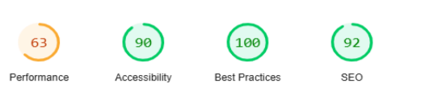

**Step 4:** Cross-Browser and Device Testing Browser Testing: ● Tested the marketplace on Chrome and Firefox to ensure consistent rendering and functionality. Device Testing: ● Manually tested the marketplace on a physical mobile device to confirm that it displays and functions correctly.

**Step 5**: Security Testing API Communication: ● Ensured that API calls should ideally be made over HTTPS, though currently, the API is still using HTTP. This needs to be addressed for secure communication. Sensitive Data Handling: ● Stored sensitive data, such as API keys, in environment variables, ensuring better security practices

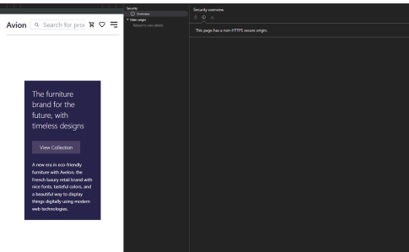

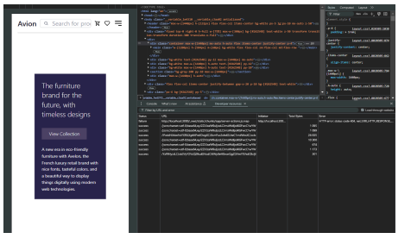

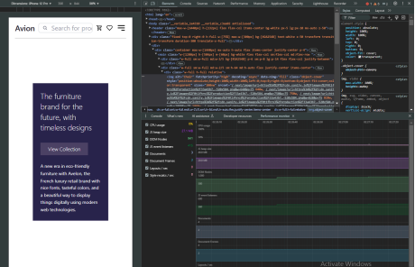

**Step 6:** User Acceptance Testing (UAT) Simulate Real-World Usage: ● Simulated real-world usage, including browsing products, adding items to the cart, and checking out. ● All workflows were intuitive and functioned correctly without errors. Conclusion Day 5 focused on thorough testing and optimization of the marketplace to ensure it operates smoothly, handles errors efficiently, and offers an enhanced user experience across a variety of devices and browsers. The platform’s core functionalities, error handling mechanisms, performance optimization, security features, and overall usability were rigorously tested and refined. With these improvements, the marketplace is now better prepared for deployment, offering a robust and user-friendly experience

**Testing CSV Report:**

